NACP Synthesis Project: "Spatial and Temporal Distributions of Sources for non-CO₂ Greenhouse Gases (CH₄, CO, N₂O) over North America"
Organized by: S. C. Wofsy, Harvard University; J. Eluszkiewicz, AER; A.Andrews, NOAA-ESRL

The above synthesis project, recently funded by NASA, is inviting you to participate. We will collect comprehensive data for concentrations and fluxes of CH₄, CO, and N₂O, and develop and publish top-down estimates of fluxes from North America, seasonally/spatially resolved.

Motivation for the synthesis
The non-CO₂ greenhouse gases (CH₄, CO, N₂O) are a major focus for the NACP (Harriss and Wofsy, 2001). CH₄ and N₂O together account for almost half of the radiative forcing attributed to CO₂ (Fig. 1). Measurements of CO are also integral to the NACP, since CO is a tracer for CO₂ emitted from mobile sources and biomass fires [e.g. Gerbig et al. 2003; Geels et al., 2004] and CO helps to define factors influencing tropospheric O₃, another key contributor to radiative forcing (Fig. 1).

A wealth of data has been collected by NACP and other projects defining the spatial and temporal distributions of these gases, as summarized in part in Table 1. Several papers have derived bottom-up inventories [e.g. Kort et al., 2008; Chen et al., 2006 (CH₄); Hirsch et al., 2006 (N₂O); Olivier et al., 2005], but these efforts have not been combined or utilized in a comprehensive top-down analysis. A comprehensive data base containing the large number of recent observations is needed for top-down validation and improvement of emission inventories.

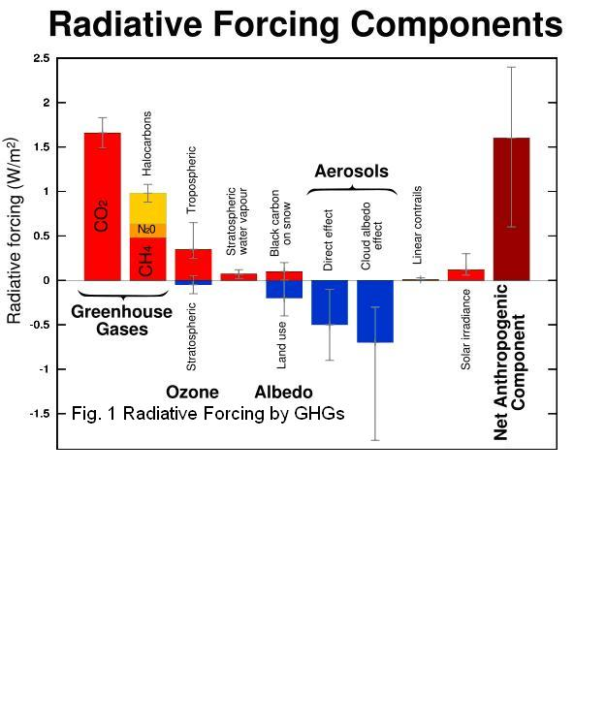

This is therefore an ideal time to carry out the proposed synthesis of data for non-CO₂ Greenhouse Gases (CH₄, CO, N₂O) over North America to produce definitive top-down analysis of their sources in North America.

Table 1: Data sets for non-CO₂ Greenhouse Gases (partial, preliminary)

A. On-going monitoring
Organization | Altitude | Measurement type | Locations
Environment Canada | Surface stations | Continuous and flasks | Alert, Alberta, Fraserdale,
NOAA Tall Towers | Profiles in the lowermost PBL | Weekly, Daily flasks; CO₂, CO, CH₄; continuous starting 2007 | WLEF, Waco, Maine, 4 others
NOAA aircraft | 0-7 km (many, starting 2000) | Monthly, Weekly; flasks | MA, NH, WLEF, MA, CO, others
AmeriFlux | Surface stations | Continuous (CO, CO₂)) | MA

B. Aircraft Campaigns
Mission | Altitude | Measurement type | Locations
COBRA-2003 | 0 - 10 km, ca. 400 profiles | Continuous, flasks | Northern US and Southern Canada, summer
INTEX-A (2004) | 0 - 10 km, ca. 200 profiles | Continuous, flasks | Northern US and Southern Canada, summer
COBRA-2004 | 0 - 8 km, ca. 900 profiles | Continuous, flasks | NE US and SE Canada, summer
CLASSIC (2007) | 0 - 8 km | Continuous, flasks | Midwest US
START08/pre-HIPPO; ARCTAS | 0 – 14 km | Continuous, flasks; DC-8, HIAPER | US Midwest, central/arctic Canada, Alaska

Goals of the Synthesis activity

1. Develop a comprehensive data base in uniform, accessible format.
2. Create a set of bottom-up inventories with best possible spatial and temporal resolution, disaggregated by source type.
3. Coordinate and/or undertake top-down validation and improvement of emissions inventories to create a set of synthesis products at various scales from regional to continental, defining emissions of these gases in the NACP domain.

The synthesis products will be designed to address societal needs for better quantitative knowledge of greenhouse gas sources in N. America.

The data products of recent and ongoing programs will be the foundation for the results from the synthesis, and the scientists active in these projects will be key collaborators. Each collaborator will have an ownership stake in the products, engendered by participation in the workshop and in the work of the synthesis, and in authorship of the published products.

Schedule of Proposed activities

- November, 2008: Three-day Workshop with 20 participants at Harvard to plan the study. .
- September 2008-January, 2008: Data assembly and preparation of WRF winds at AER, BRAMS winds at Harvard.
- January, 2009-July, 2009: Inversion studies.
- July, 2009: Workshop with 25 participants at Harvard to assess the analyses, and set reporting and publication activities.
- August-December, 2009: Preparation of publications and reports.
- March, 2009: Publications complete.

Total duration 18 months.

Attendees: see Appendix

Deliverables:
- Comprehensive data base, served at a major data archive center.
- Scientific papers devoted to analysis of the budgets of non-CO₂ greenhouse gas emissions from North America. These papers will have multiple authors (or a group/committee author) representing a broad cross-section of the scientific community and will deal with issues including sampling, analysis, attribution, uncertainties, and development of measurement recommendations.
- NACP/CCSP Special Report, written for decision support and for the public, discussion US and North American contributions to non-CO₂ greenhouse gas emissions during the period 2000-2007. It will include assessment of the source magnitudes, discussion of attribution, and recommendation for sampling and measurement priorities for the future.

References

Chen, Y.-H., and R. G. Prinn (2006), Estimation of atmospheric methane emissions between 1996 and 2001 using a three dimensional global chemical transport model, J. Geophys. Res., 111, D10307, doi:10.1029/2005JD006058.

Eluszkiewicz, J., T. Nehrkorn, S. C. Wofsy, D. Matross, C. Gerbig, J. C. Lin, S. Freitas, M. Longo, A. E. Andrews, W. Peters, and B. Daube (2008), Regional Simulations of Tower-Based and Airborne CO₂ Measurements With the Coupled Weather Research and Forecasting/ Stochastic Time-Inverted Lagrangian Transport/Vegetation Photosynthesis and Respiration Models, (in review) J. Geophys. Res.

Geels, C., S. C. Doney, R. Dargaville, J. Brandt, J. H. Christensen (2004) Investigating the sources of synoptic variability in atmospheric CO₂ measurements over the Northern Hemisphere continents: a regional model study Tellus B 56 (1) , 35–50 doi:10.1111/j.1600-889.2004.00084.x

Gerbig, C., J. C. Lin, S. C. Wofsy, B. C. Daube, A. E. Andrews, B. B. Stephens, P. S. Bakwin, and C. A. Grainger, Towards constraining regional scale fluxes of CO2 with atmospheric observations over a continent: 1. Observed Spatial Variability, J. Geophys. Res. 108,. D24, 4756 (14 pp) , 2003.

Hirsch, A. I., A. M. Michalak, L. M. Bruhwiler, W. Peters, E. J. Dlugokencky, and P. P. Tans (2006), Inverse modeling estimates of the global N2O surface flux from 1998–2001, Global Biogeochem. Cycles, 20, GB1008, doi:10.1029/2004GB002443.

Kort, Eric A., J. Eluszkiewicz, B. B. Stephens, J. B. Miller, C. Gerbig, T. Nehrkorn, B. C. Daube, J. O. Kaplan, S. Houweling, and S. C. Wofsy (2008), Emissions of CH4 and N2O over the United States and Canada based on a receptor-oriented modeling framework and COBRA-NA atmospheric observations, submitted to GRL

Olivier, J.G.J., Van Aardenne, J.A., Dentener, F., Ganzeveld, L. and J.A.H.W. Peters (2005), Recent trends in global greenhouse gas emissions: regional trends and spatial distribution of key sources. In: “Non-CO2 Greenhouse Gases (NCGG-4)”, A. van Amstel (coord.), page 325-330. Millpress, Rotterdam, ISBN 90 5966043 9.

Appendix. List of potential participants.

PIs: Janusz Eluszkiewicz
Steven C. Wofsy

NOAA collaboration leader; Arlyn E. Andrews

- Elliot Atlas
- Don Blake
- Lori Bruhwiler
- Mous Chahine
- Patrick Crill
- Ed Dlugokencky
- James W.Elkins
- Marc Fischer
- Wei Min Hao
- Adam Hirsch
- Dale Hurst
- Daniel Jacob
- Jed Kaplan
- John C. Lin
- Wallace McMillan (AIRS)
- Anna Michalak
- John Miller
- Steve Montzka
- Colm Sweeney
- Margaret Torn
- Marek Uliasz
- Katey Walters
- Paul Wennberg
- Doug Worthy

